**MAVEN WEBAPP**

1. **Open Eclipse, Go to File->New->Maven Project**

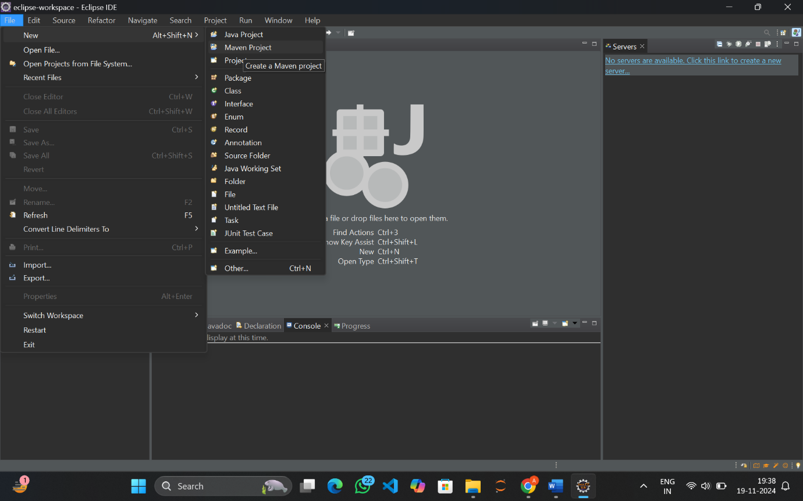

1. **Click on Next**

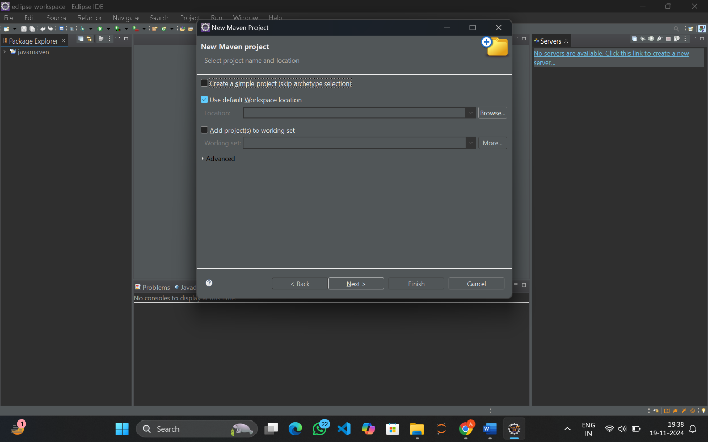

1. **In the filters type org.apache.maven**

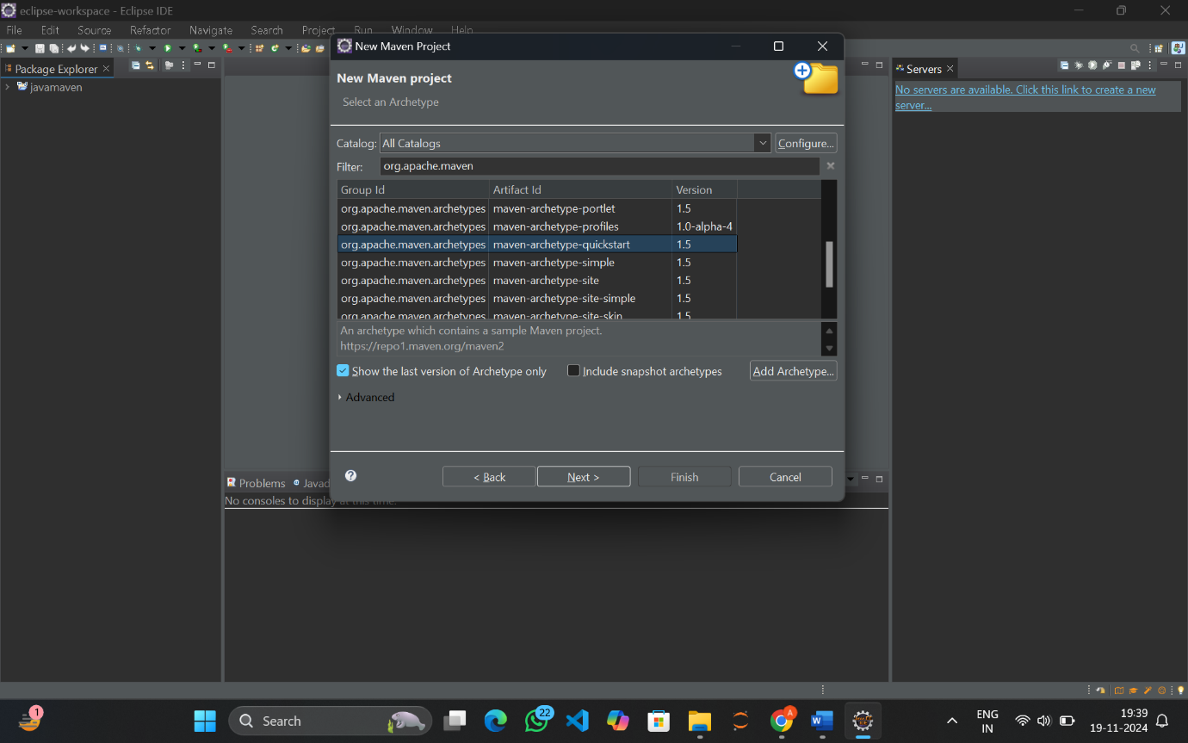

1. **Select maven-archetype-quickstart**
2. **Let the group Id be com.app.demo and artifact Id as webapplication**

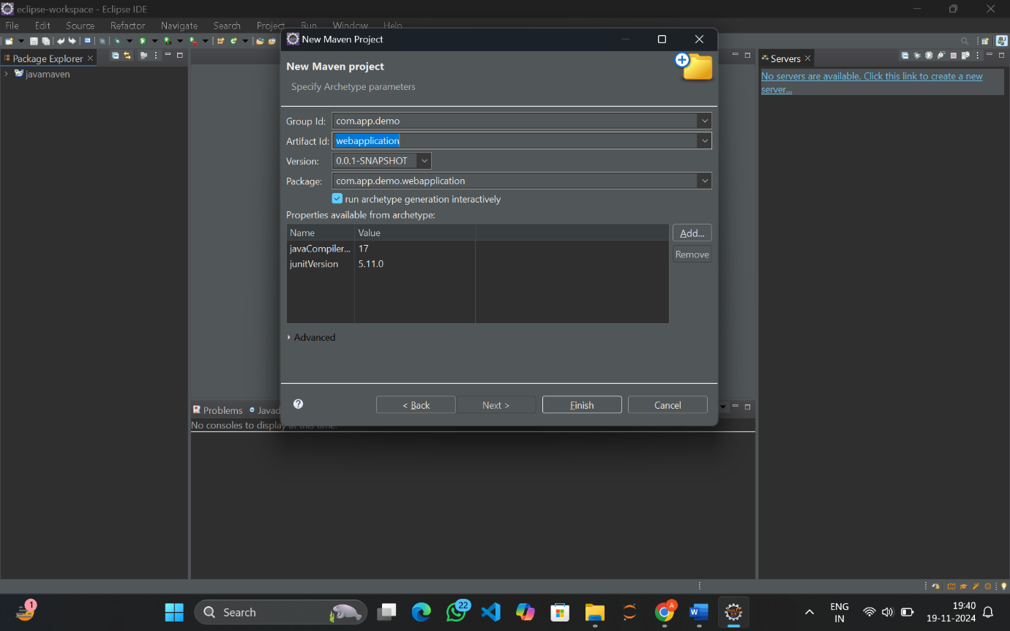

1. **Click on Finish and you can the download starts, Type Y in console**

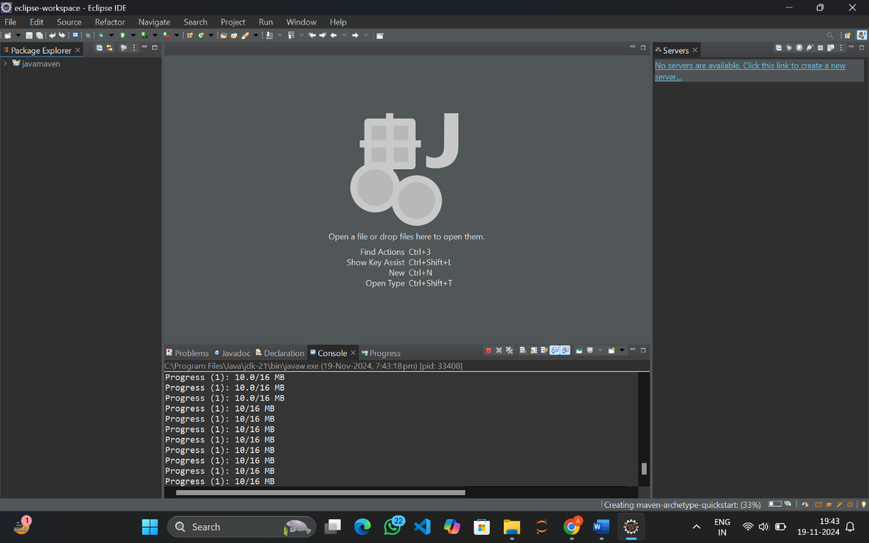

1. **The build was successful**

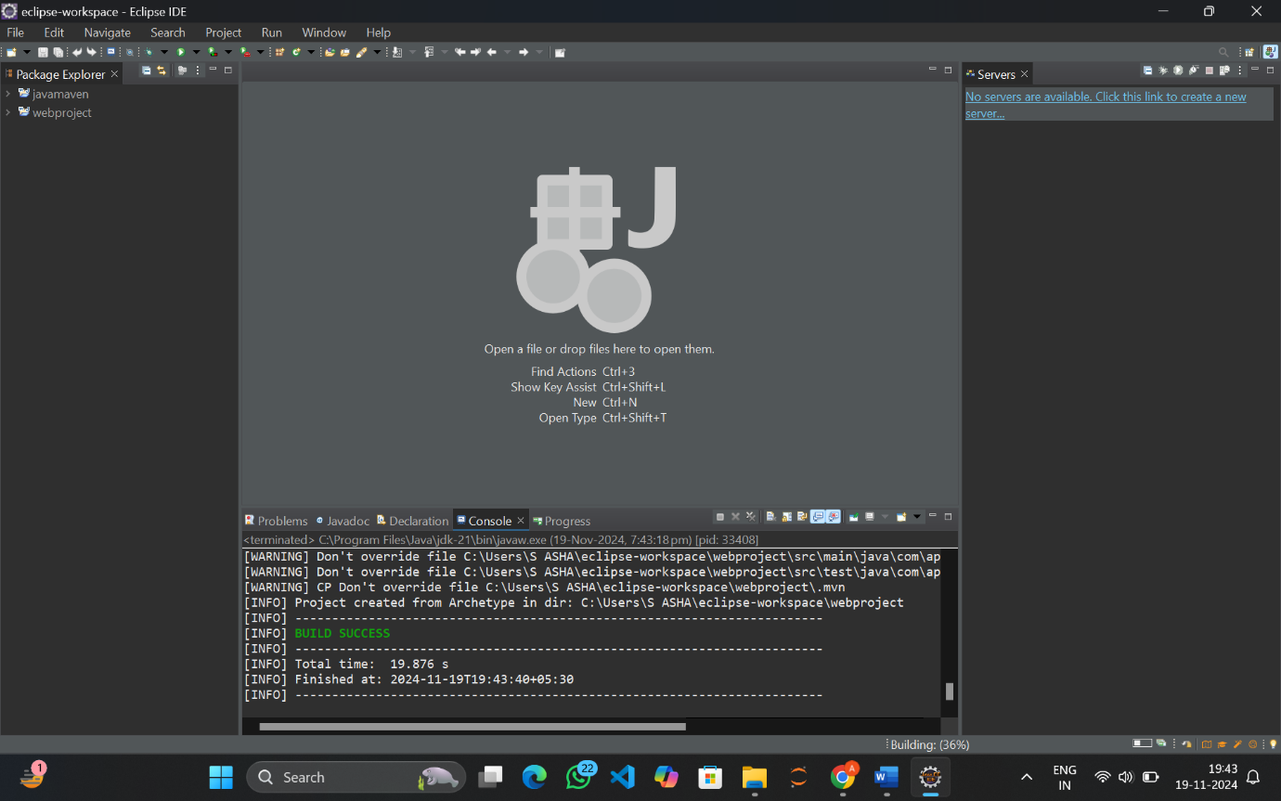

1. **Go to Google and search maven servlet dependency**

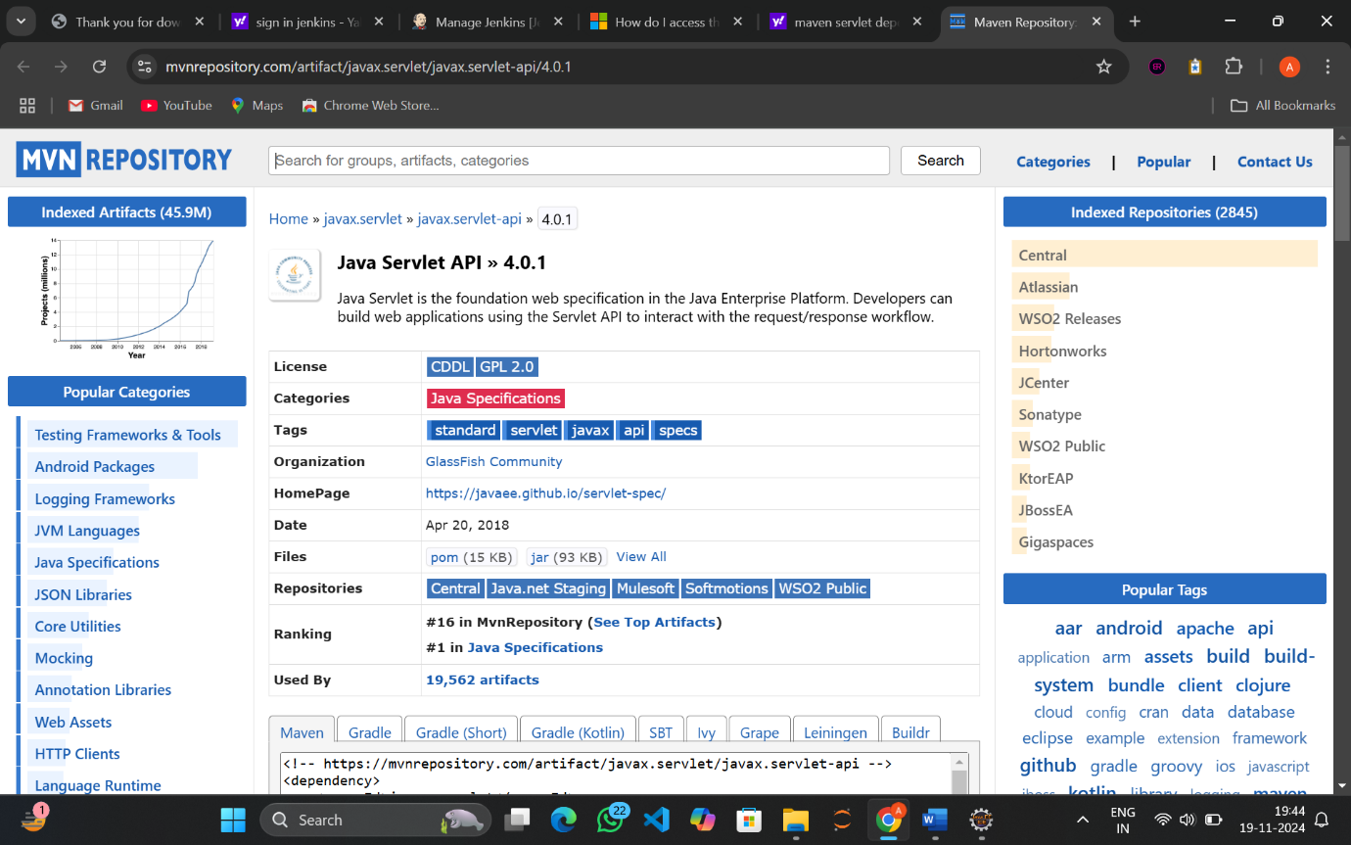

1. **Click on the link**



1. **Click on the 2.5 version**

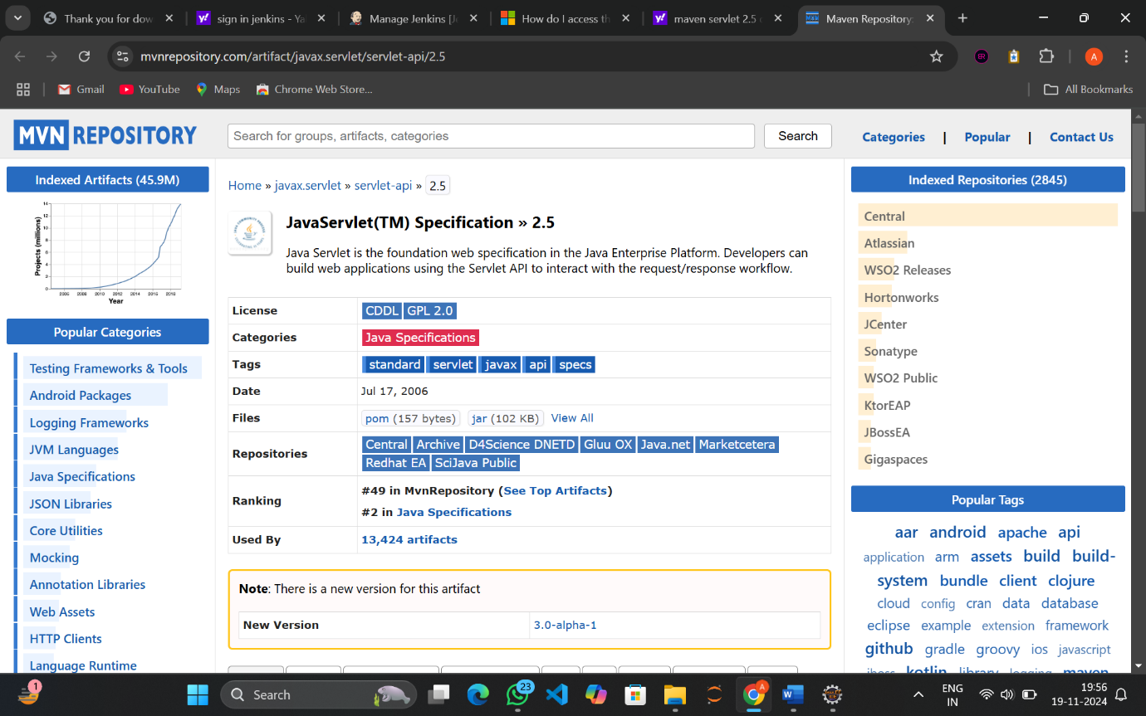

1. **Copy the code**

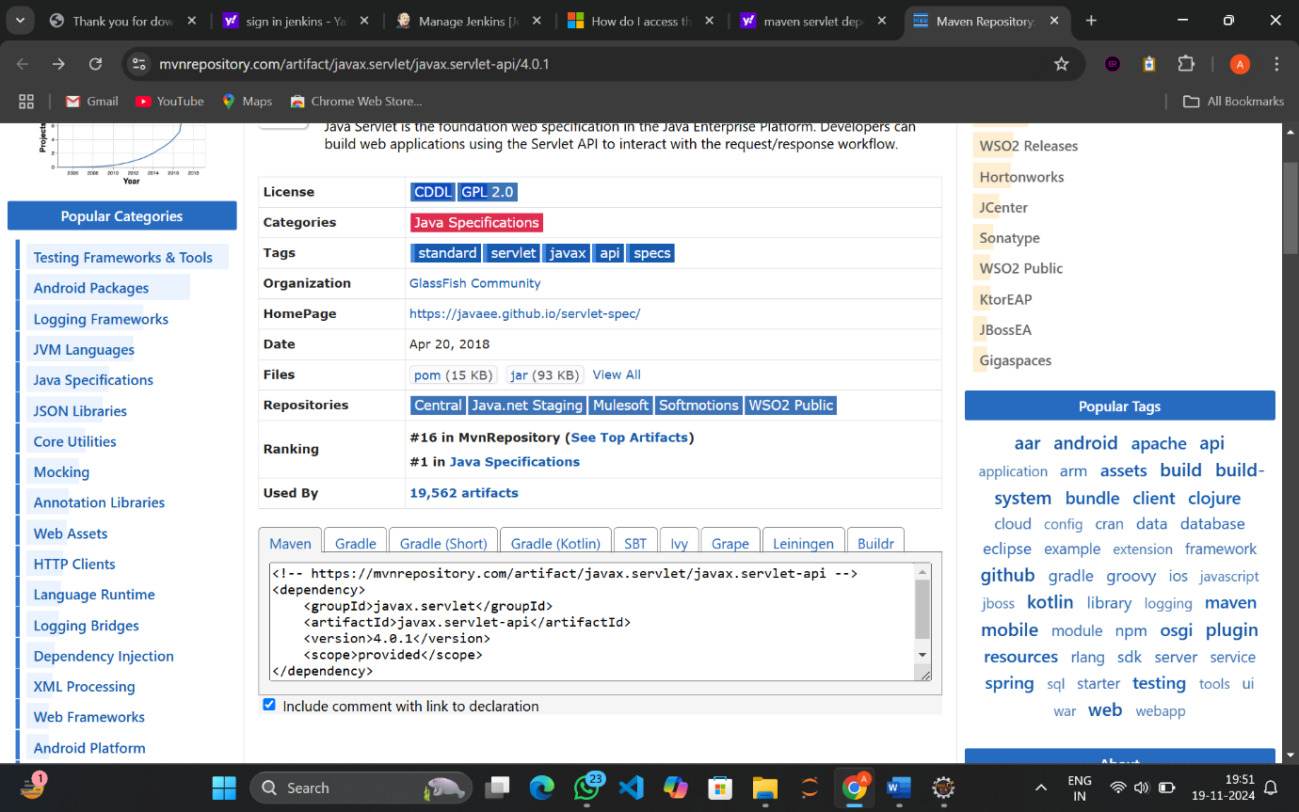

1. **Paste it in the pom.xml file under the dependencies tag and save changes**

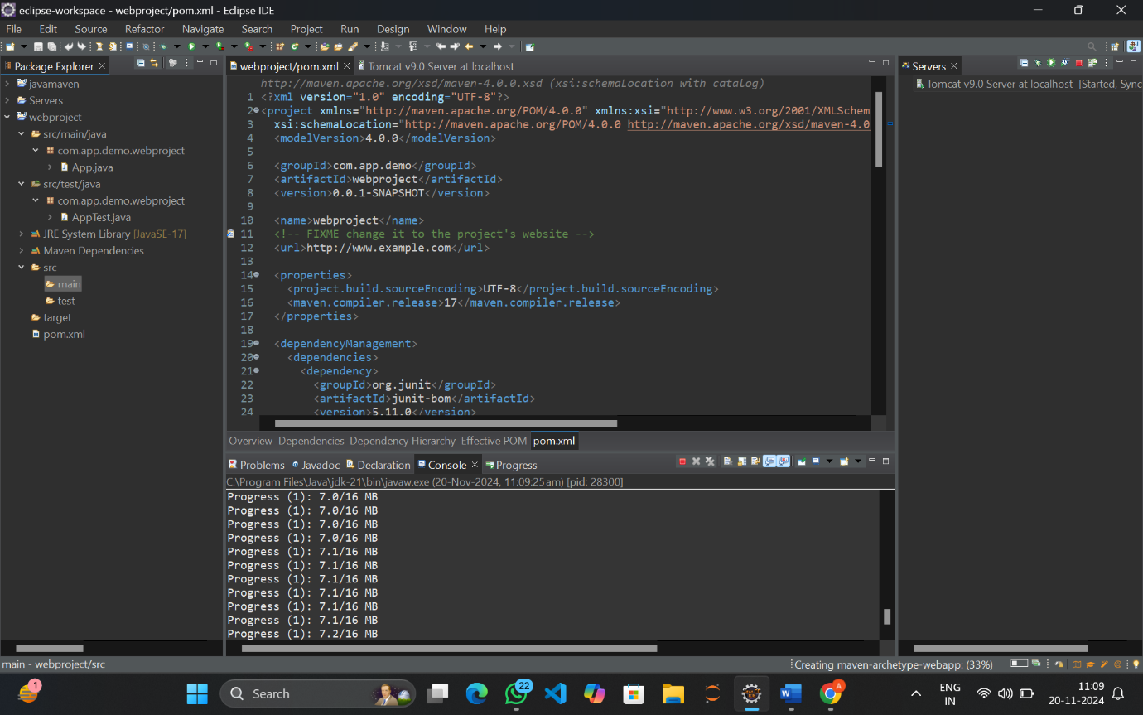

1. **Now Start the Server**
2. **The server is started**

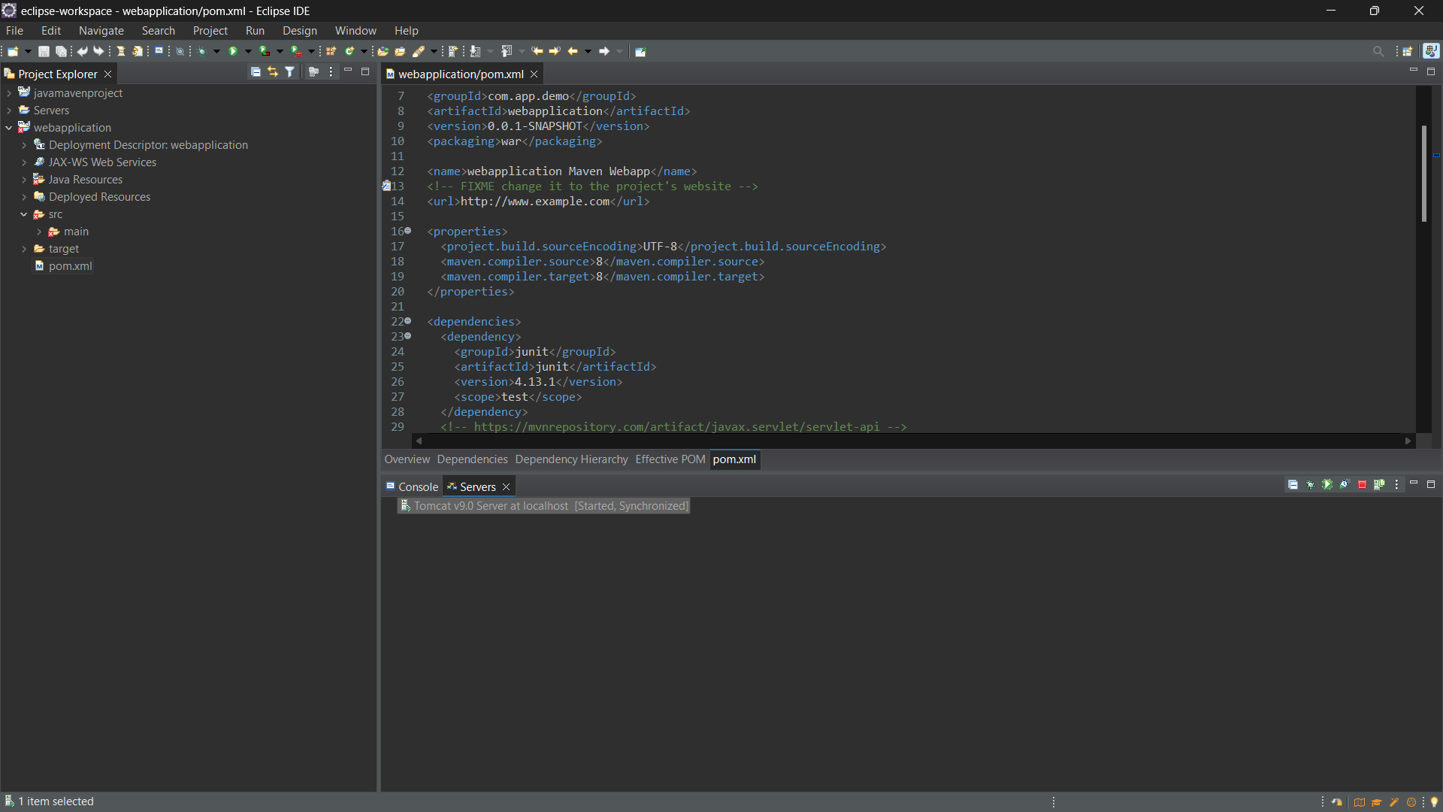

1. **Open the index.jsp file under src->main->webapp**
2. **Right click and Select Run As-> Run on server**

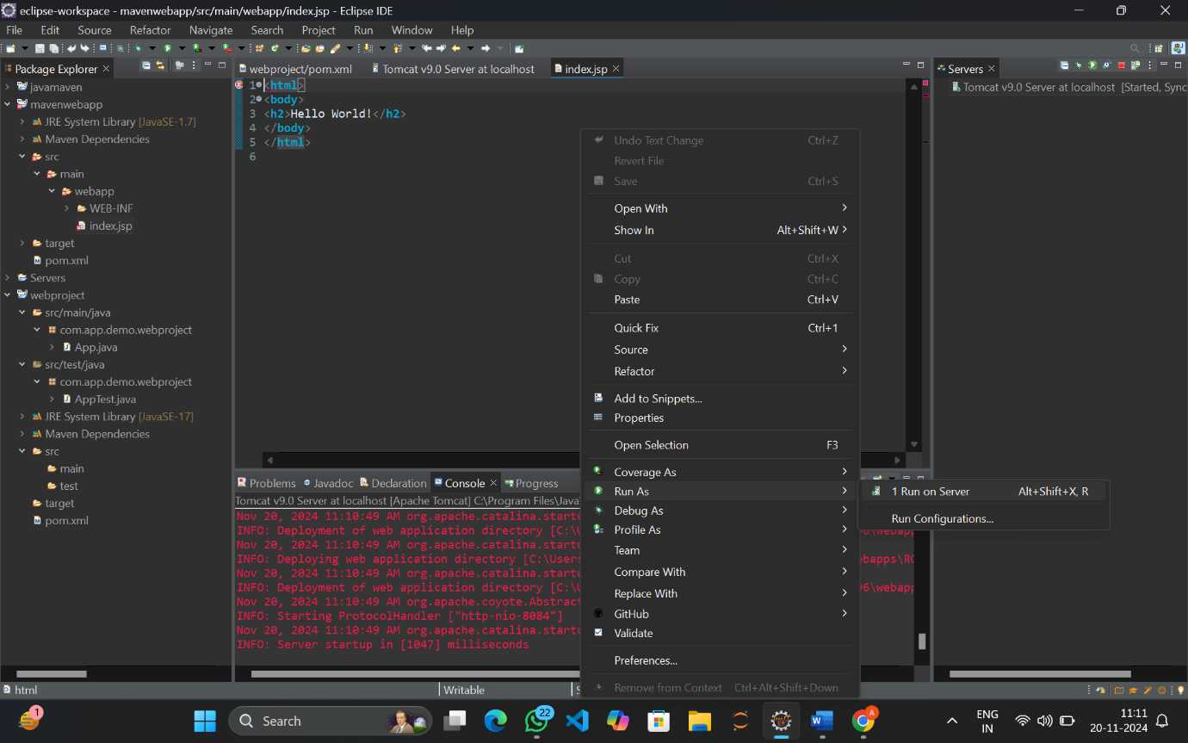

1. **The following box appears, select the sever**

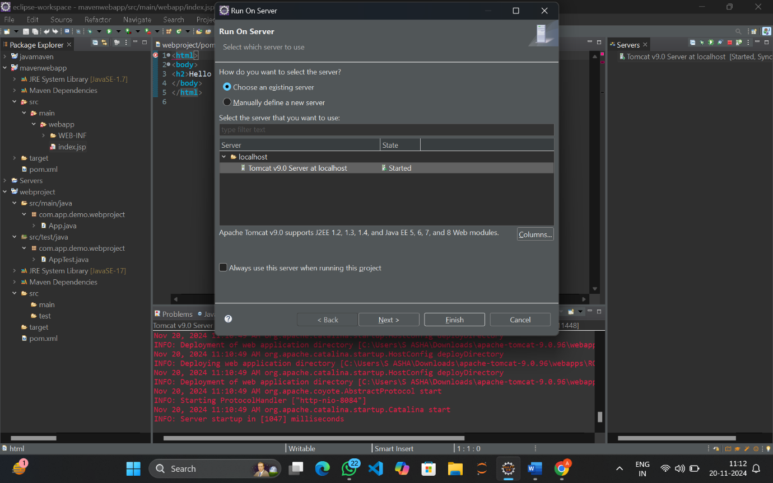

1. **We have out webapplication on the configured side, Click Finish**
2. **ReStart the server**

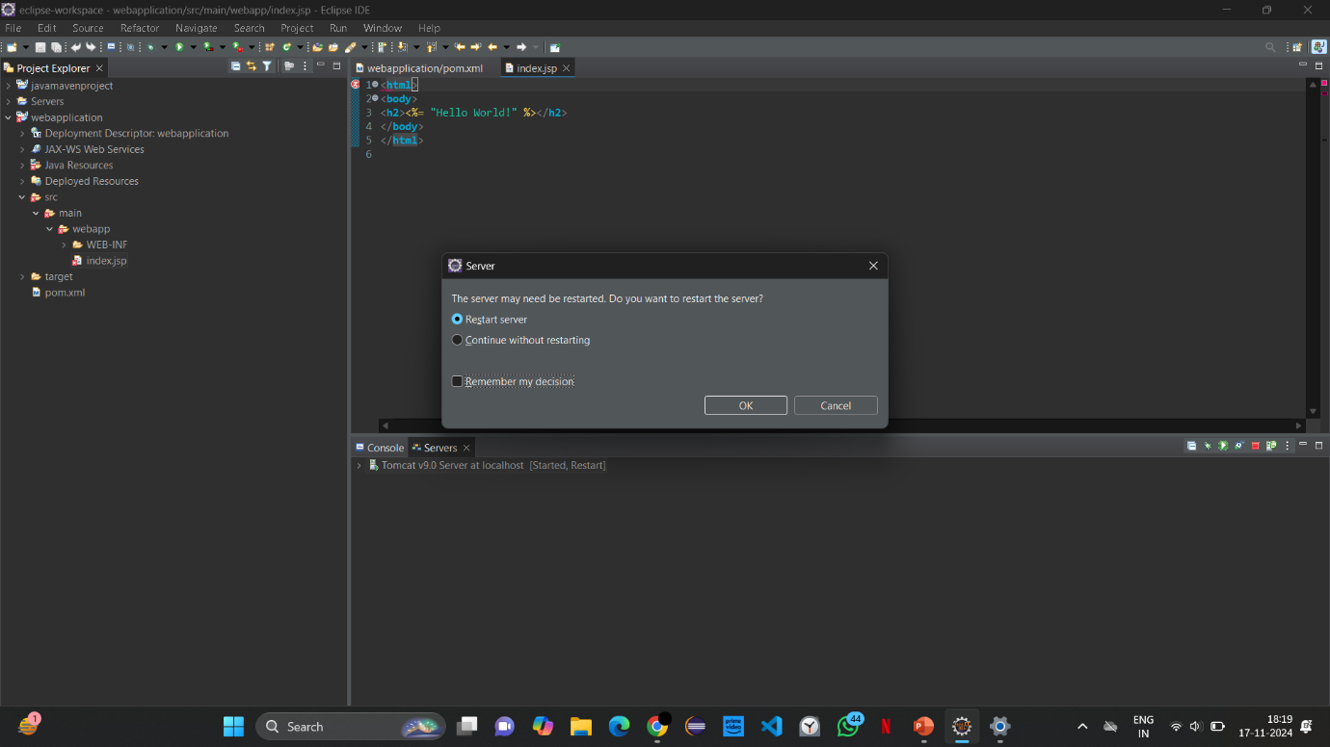

1. **The server opens on the browser**

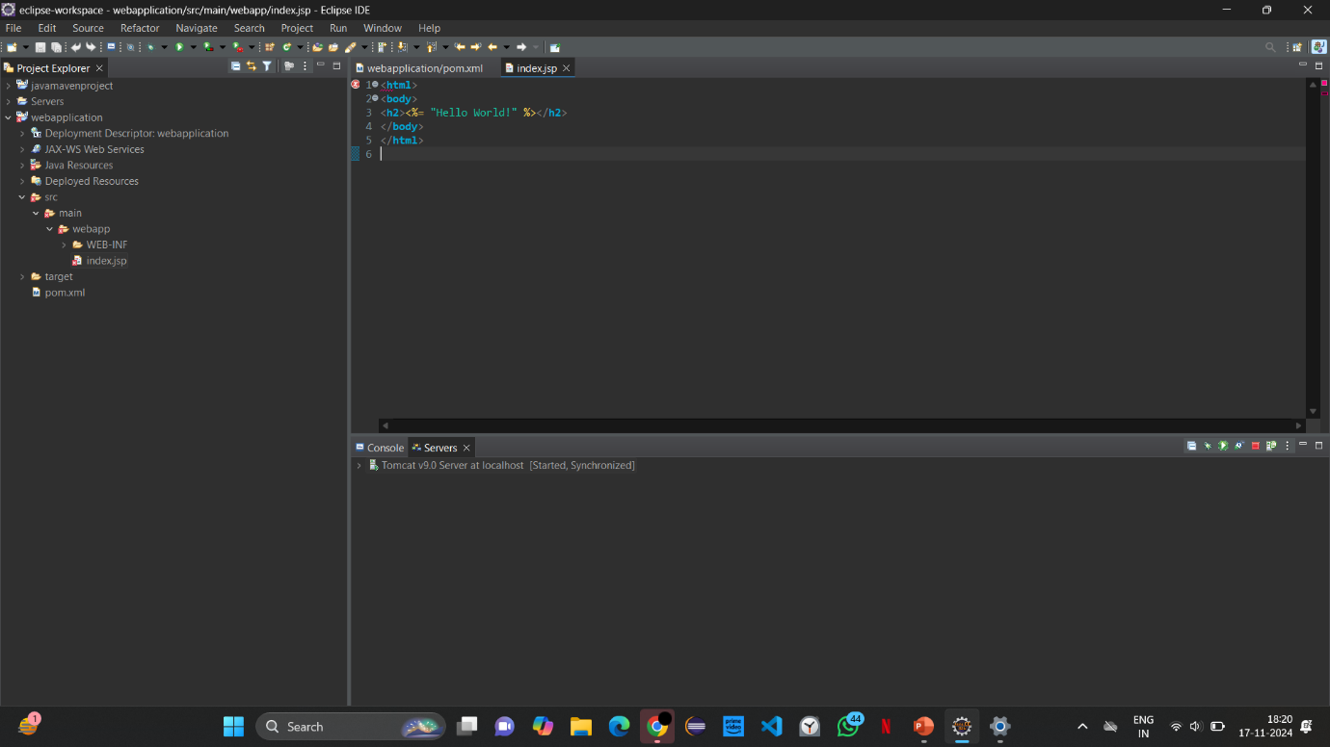

1. **You can see Hello World when you open the browser**

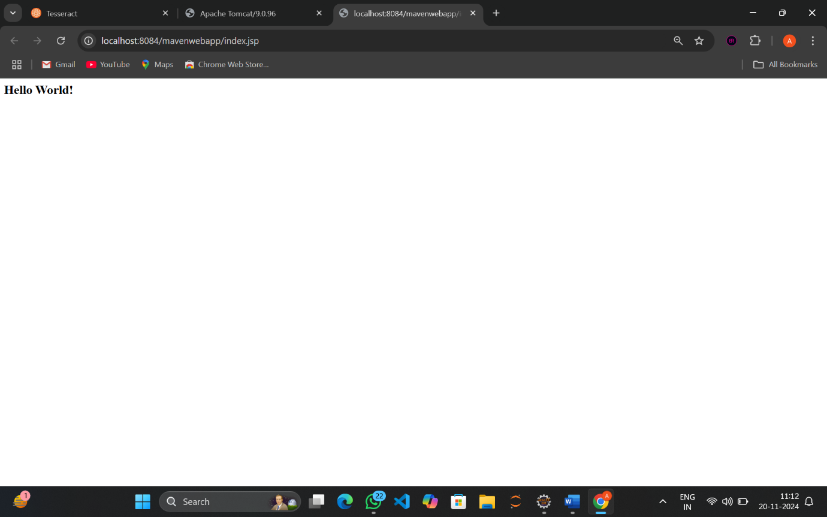

1. **Navigate to the manager site and type the username and password**

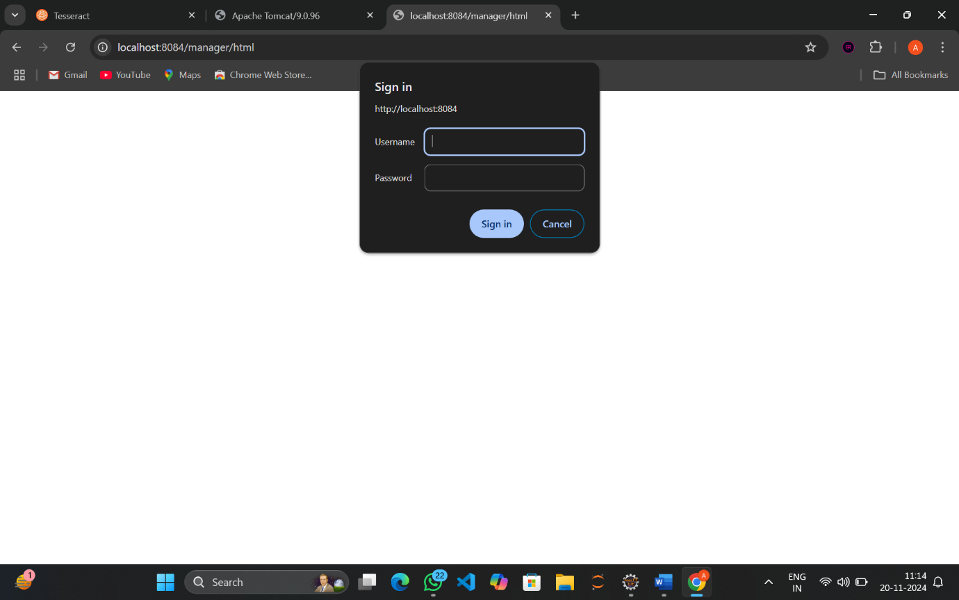

1. **SIGN IN**



1. **The Manager Application is opened**





